Fields and Records Setup
Reason Code Record
ID customrecord_reason_code
List
Late Days Buckets
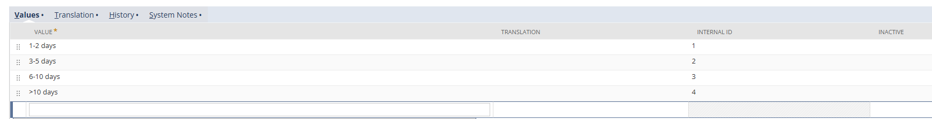

No | Label | ID | Type | Apply to | Display
1 | Reason Code | custbody_reasoncode_header | Free-Form Text | Sales Order | Sales
2 | Reason Description | custbody_reasoncode_description | Free-Form Text | Sales Order | Sales
3 | Reason Code | custcol_reasoncode_line | Free-Form Text | Sales Order
4 | Actual Ship Date | custcol_actualshipdate | Date
5 | Late Days | custcol_latedays | Integer
6 | Late Days Bucket | custcol_latebucket | List

Scripts Setup
UE_item_fulfillment.js
UE_SO_reasoncode.js
CS_SO_2.1.js

Report Setup
Late % by Reason Code
 | 2A | 3B | DD | FE
% | 21% | 10% | 5% | 13%

Late % by Days Bucket
 | 1-3 Days | 3-5 Days | 6-10 Days | >10 Days
% | -- | -- | -- | --

Late % by Department or Area

Overall On-Time Percentage

